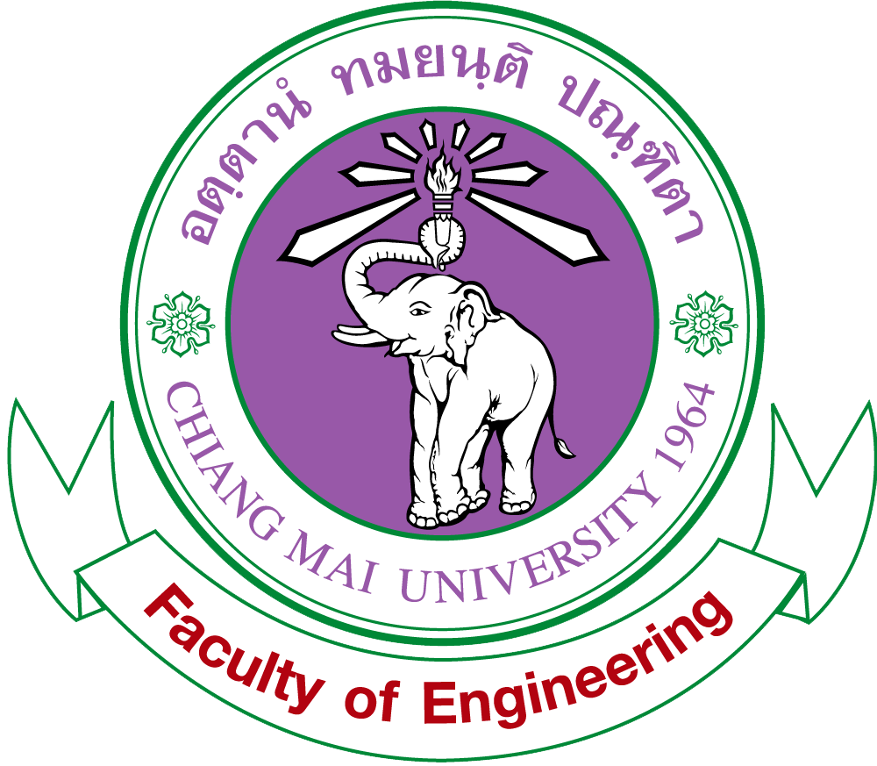
คณะวิศวกรรมศาสตร์ มหาวิทยาลัยเชียงใหม่
239 ถนนห้วยแก้ว ตำบลสุเทพ อำเภอเมือง จังหวัดเชียงใหม่ 50200
Faculty of Engineering, Chiang Mai University, THAILAND 50200
Tel: +66(53)944176-7 Fax: +66(53)942044, 217287 http://www.eng.cmu.ac.th

Ref.No.MOE 6593(14)/

April , 2018
Managing Director of Georg Jensen (Thailand) Co.,Ltd.
138 Moo 1 Chiang Mai-Sankampang Rd.
Tonpao San Kamphaeng Chiangmai 50130

Dear Managing Director of Georg Jensen (Thailand) Co.,Ltd.,

Ms. Chanyabhak Siripanich. She is a graduate student of Department of Industrial Engineering, Faculty of Engineering, Chiang Mai University and currently undertaking independent study titled “Defect Reduction of Gemstone in Jewelry Industry Using Knowledge Management System”. She is currently conducting the research under the supervision of Associate Professor Dr. Nivit Charoenchai. She is currently in the process of collecting data for the study. The objective of this research is to apply Knowledge Management System to reduce defect in the production process of gemstones. Therefore, She would like to request for your kind consideration to collecting data in Georg Jensen (Thailand) Co.,Ltd. The collected data will be used strictly for this research only.

We appreciate your kind consideration. For further clarifications, please do not hesitate to contact
Ms. Chanyabhak Siripanich at Email chanyabhak.s@georgjensen.co.th. or via mobile number 080-0545115. Looking forward to hearing from you soon.

Yours sincerely,

Phrut Sakulchangsatjatai, Ph.D.
Associate Professor in Mechanical Engineering
Acting Dean for Research, Academic Services
and Graduate Programs
Faculty of Engineering
Chiang Mai University

